+ 

ANUDIP FOUNDATION

**Project Title**

**“House Rental System”**

**By**

|  |  |
| --- | --- |
| **Name** | **Enrollment No** |
| Nikita Autade | AF0481820 |

**Under Guidance of**

**Rajshri Thete**

**ABSTRACT**

The House Rental System is a web-based application designed to simplify the process of renting and managing residential properties. Developed using Python for backend logic, SQL for database management, and HTML, CSS, and JavaScript for the frontend interface, the system provides a user-friendly platform for property owners and tenants.

This project aims to digitize the traditional rental process by enabling property owners to list available houses or apartments, while allowing tenants to browse, search, and request rentals online. The system includes core functionalities such as user registration, login authentication, property listing, search filters (by location, price, type, etc.), and booking requests. Admin functionalities are also integrated to manage users, property approvals, and resolve disputes.

The backend, powered by Python and SQL, ensures secure data handling, efficient query processing, and smooth interaction between the client and the server. The responsive frontend interface, crafted with HTML, CSS, and JavaScript, enhances user experience by providing intuitive navigation and dynamic content updates.

Overall, this House Rental System streamlines rental operations, reduces manual efforts, and provides a scalable solution suitable for both small-scale and large-scale real estate use cases**.**

**ACKNOWLEDGEMENT**

The project **“House Rental System”** is the Project work carried out

by

|  |  |
| --- | --- |
| **Name** | **Enrollment No** |
| Nikita Autade | AF0481820 |

Under the Guidance:-

**Rajshri Thete**

We are thankful to my project guide for guiding me to complete the Project.

Her suggestions and valuable information regarding the formation of the Project Report have provided me a lot of help in completing the Project and its related topics.

We are also thankful to my family member and friends who were always there to provide support and moral boost up.

|  |  |
| --- | --- |
| **TOPIC OF THE PROJECT** |  |
| 1. ***Title of the Project*** 2. ***Introduction/Objective***     1. ***Introduction***    2. ***Objective*** 3. ***System Analysis***     1. ***Problem Definition***    2. ***Preliminary Investigation***    3. ***Feasibility Study***    4. ***Project Planning***   ***3.5 Project Scheduling***   * 1. ***Software Requirement Specification***   ***3.7 Functional Requirements***  ***Software Engineering Paradigm***   1. ***System Design***     1. ***Modularization Details***    2. ***Database Design***    3. ***Procedural Design***    4. ***User Interface Design***      1. ***Coding***     1. ***Complete Project Coding***    2. ***Error Handling*** |  |
| ***5.3. Code Improvement***     1. ***Testing*** 2. ***System Security Measure***   ***Security Strategies***   1. ***Reports*** 2. ***Future Application of the Project***      1. ***Bibliography*** |  |

**HOUSE RENTAL SYSTEM**

**INTRODUCTION**

The **House Rental System** is a web-based application developed using **Python (Django)**, **SQL**, **HTML**, **CSS**, and **JavaScript**, aimed at modernizing and streamlining the residential property rental process. This project serves as a digital bridge between property owners and potential tenants by providing an intuitive, centralized platform for listing and renting houses or apartments.

With the growing demand for digital solutions in the real estate sector, the system enables users to search, filter, and request rental properties based on various criteria such as location, price range, and property type. Property owners can register and list their properties with detailed descriptions, images, and rent information, while tenants can create accounts, browse available listings, and make rental requests.

Key features include user authentication, role-based access for admins, owners, and tenants, property management, booking and approval workflows, and dynamic frontend interactions. Admins have full control over user activities, listing verifications, and system analytics to ensure a secure and transparent rental process.

This House Rental System not only reduces the hassle of manual property renting but also expands the visibility of properties beyond local boundaries, making the rental process more efficient, secure, and accessible for all stakeholders.

### ****Objectives****

The main objectives of the e-Farming System are:

• **To develop a user-friendly web-based platform** that simplifies the process of renting residential properties using Python for backend development.

• **To facilitate seamless communication** between property owners and tenants by providing secure login, registration, and user role management.

• **To enable property owners** to list their rental properties with complete details such as rent amount, location, property type, images, and availability.

• **To allow tenants** to search, view, and filter properties based on various criteria like price range, number of rooms, location, and amenities.

• **To implement a booking and request system** where tenants can

send rental requests and owners can accept or reject .

• **To manage property data efficiently** using a relational database (SQL) for storing user information, property listings, and rental transactions.

• **To design a responsive and interactive front-end** using HTML, CSS, and JavaScript to improve user experience across devices.

• **To integrate an admin panel** for monitoring user activities, managing listings, and generating basic reports and analytics.

• **To ensure data security and system reliability** through secure authentication mechanisms and error-handling techniques.

• **To reduce dependency on traditional rental methods** by providing a scalable digital alternative for property management and rentals.

**SYSTEM ANALYSIS**

**PROBLEM DEFINITION**

**In the Absence of Adequate Security in the House Rental System:**

* **User privacy is compromised**: Tenants’ and landlords’ personal data (e.g., contact, ID proofs, rental details) could be leaked or stolen.
* **Misuse of data**: Property or user information could be misused—such as posting fake listings, unauthorized access to property details, or fraudulent bookings.
* **Concurrent access issues**: Multiple users accessing the platform simultaneously may lead to booking conflicts, data mismatch, or system slowdowns if concurrency is not managed securely.
* **Loss of trust**: Users may avoid the platform if they face data breaches or payment issues, leading to reduced adoption and reliability of the digital system.

**PRELIMINARY INVESTIGATION:**

# Purpose –

**–**  
To build a digital platform that enables landlords to list rental properties and tenants to browse and request rentals online—anytime, anywhere—reducing the dependency on agents and increasing convenience for all users.

# Benefits-

* Eliminates the need for third-party brokers and physical property visits at the initial stage.
* Easy access to updated rental listings with photos, prices, and availability.
* Promotes consistent user engagement through convenience and speed.
* Facilitates digital communication via email alerts and SMS confirmations.
* Reduces manual paperwork and administrative overhead for both tenants and property owners.

# Proposed System -

The proposed **House Rental System** includes:

* A secure, scalable web platform for managing rental listings and requests.
* Features for users to register, list properties, and browse/filter rental options.
* Digital booking system with status tracking and request history.
* Automatic email notifications on successful bookings or changes in request status.
* Centralized and secure data storage for user accounts, listings, and transactions.
* Admin dashboard for managing users, approving listings, and handling support requests.

**Technical Specifications**

* **Frontend:** HTML, CSS, JS
* **Backend:** Django (Python framework)
* **Database:** MySQL
* **Other Tools:** JavaScript

## REQUIREMENT SPECIFICATIONS

• **Reliability:** The system can support multiple user interactions simultaneously without crashing or data loss.

• **Organization:** Clear distinction between roles (admin, property owner, tenant) with structured workflows.

• **Correctness:** All property data, bookings, and user inputs are processed and stored accurately.

• **Usability:** Simple, clean user interface accessible across devices and browsers.

• **Maintainability:** Easy to manage and update listings, fix bugs, and add or remove features.

• **Expandability:** Can be extended to include features like online rent payment, property reviews, or location maps.

• **Portability:** Can be deployed on local servers or cloud platforms like AWS, Heroku, or PythonAnywhere.

• **Accurateness:** Ensures data validity with no duplicate bookings, incorrect information, or missing fields.

• **Error-handling:** Handles invalid operations gracefully and logs all issues for troubleshooting.

• **Communication:** Users receive timely email alerts on account activities, booking statuses, and listing updates.

FEASIBILITY STUDY

A feasibility study is an evaluation of a proposal designed to determine the difficulty in carrying out a designated task. Generally, a feasibility study precedes technical development and project implementation. In other words, a feasibility study is an evaluation or analysis of the potential impact of a proposed project

We can also say that a feasibility study is a detailed analysis of a company and its operations that is conducted in order to predict the results of a specific future course of action. Small business owners may find it helpful to conduct a feasibility study whenever they anticipate making an important strategic decision. For example, a company might perform a feasibility study to evaluate a proposed change in location, the acquisition of another company, a purchase of major equipment or a new computer system, the introduction of a new product or service, or the hiring of additional employees. In such situations, a feasibility study can help a small business's managers understand the impact of any major changes they might contemplate.

**Steps in Conducting a Feasibility Study:**

The main objective of a feasibility study is to determine whether a certain plan of action is feasible—that is, whether or not it will work, and whether or not it is worth doing economically. Although the core of the study is dedicated to showing the outcomes of specific actions, it should begin with an evaluation of the entire operation. For example, a good feasibility study would review a company's strengths and weaknesses, its position in the marketplace, and its financial situation. It would also include information on a company's major competitors, primary customers, and any relevant industry trends. This sort of overview provides small business owners and managers with an objective view of the company's current situation and opportunities. By providing information on consumer needs and how best to meet them, a feasibility study can also lead to new ideas for strategic changes.

The second part of a good feasibility study should focus on the proposed plan of action and provide a detailed estimate of its costs and benefits. In some cases, a feasibility study may lead management to determine that the company could achieve the same benefits through easier or cheaper means. For example, it may be possible to improve a manual filing system rather than purchase an expensive new computerized database. If the proposed project is determined to be both feasible and desirable, the information provided in the feasibility study can prove valuable in implementation. It can be used to develop a strategic plan for the project, translating general ideas into measurable goals. The goals can then be broken down further to create a series of concrete steps and outline how the steps can be implemented. Throughout the process, the feasibility study will show the various consequences and impacts associated with the plan of action.

In most cases, a feasibility study should be performed by a qualified consultant in order to ensure its accuracy and objectivity. To be able to provide a meaningful analysis of the data, the consultant should have expertise in the industry. It is also important for small businesses to assign an internal person to help gather information for the feasibility study. The small business owner must be sure that those conducting the study have full access to the company and the specific information they need.

**Advantages of making Feasibility study:**

* There are many advantages of making feasibility study some of which are summarized below:
* This study being made as the initial step of software development life cycle has all the analysis part in it which helps in analyzing the system requirements completely. .
* Helps in identifying the risk factors involved in developing and deploying the system..
* The feasibility study helps in planning for risk analysis.

.

* Feasibility study helps in making cost/benefit analysis which helps the organization and system to run efficiently.

.

* Feasibility study helps in making plans for training developers for implementing the system.

.

* So a feasibility study is a report which could be used by the senior or top persons in the organization. This is because based on the report the organization decides about cost estimation, funding and other important decisions which is very essential for an organization to run profitably and for the system to run stable.

**Different Types of Feasibility:**

In the conduct of feasibility study, the analyst will usually consider seven distinct but inter-related types of feasibility.

The different types of feasibility studies are as follows:

* ***Technical feasibility study:*** It is used to determine the requirements of technologies for the current system.
* ***Schedule feasibility study:*** It is used to determine the time factor related to the current system.
* ***Social feasibility study:*** It is used to determine whether a proposed project will be acceptable to the people or not. This determination typically examines the probability of the project being accepted by the group directly affected by the proposed system change.
* ***Legal feasibility study:*** It is used to determine the legal scrutiny of the current system.
* ***Marketing feasibility study:*** It is used to determine the single and multidimensional market forces that affect the current system. There are four types of marketing feasibility study, which are as follows:
  1. **Economic feasibility**
  2. **Legal feasibility**
  3. **Operational feasibility**
  4. **Schedule feasibility**
  5. **Is it technically feasible or not?**

The project is made with the help of a PC is easily available.

Secondly, the software used for encryption and decryption purpose is

also easily available.

Finally, the other software used to develop this project can easily interface with each other and also compatible with Windows 2000, Windows XP, Windows Server 2003, or Windows NT 4.0 operating system.

* 1. **Is it technically feasible or not?**

This website is very user –friendly. Any user who knows simple English language can use this website. The user does not need to be familiar with .net framework or SQL server to use this website. So we can conclude that the website is operationally feasible as doing any operation in this website is very simple and it does not involve any complicacy.

* 1. **Is it economically feasible or not?**

The project is economically feasible as to install this software we need the minimum hardware configuration that we require installing Windows 2000, Windows XP, Windows Server 2003, or Windows NT 4.0whose cost is minimal. Moreover to make this software run we do not need to install any additional software except Dot Net Framework and Windows Installer 3.1. These two software’s will be installed automatically while installing our software. So, now we can easily conclude that this software is economically feasible.

* + 1. **Is it schedule feasible or not?**

The developer required only two month to develop this website. So we can say that the s website is time feasible.

* + 1. **Is it socially feasible or not?**

Yes, the developed website holds obviously social feasibility as this website does not perform any illegal operation and does not break our social law.

**PROJECT PLANNING AND SCHEDULING:**

# PROJECT PLANNING

 **Project Planning**

 **Phase To Cover**

1. Preliminary Investigation
2. System Analysis
3. System Design
4. Coding
5. Security
6. Testing
7. Implementation





**Stop**



**Start**



Preliminary



System Analysis



System Design



Coding



Testing



Security



Implementation

## SOFTWARE REQUIREMENT SPECIFICATION (SRS)

The purpose of this SRS is to define the functional and non-functional requirements of the House Rental System. This web-based platform enables property owners (landlords) to list rental properties and allows tenants to browse, request, and book accommodations online.

Scope:  
This system will streamline the house rental process by eliminating the need for brokers, reducing paperwork, and increasing accessibility to verified rental listings. It provides modules for user registration, property management, booking, and admin control.

**Data Requirements (Modules)**

**1. User Registration and Authentication Module**

**Purpose:** Allows landlords and tenants to create accounts and log in securely.  
**Functions:**

* Register with personal details (name, email, phone, password, role selection).
* Secure login with session management.
* Password recovery/reset feature.
* Role-based access (Tenant / Landlord / Admin).

**2. Property Management Module (Landlord)**

**Purpose:** Allows landlords to list and manage rental properties.  
**Functions:**

* Add new property with title, type (1BHK, 2BHK, etc.), address, rent, image, and description.
* Edit or delete existing property listings.
* View booking requests received from tenants.
* Update availability status of a listed property.

**3. Booking and Request Module (Tenant)**

**Purpose:** Enables tenants to browse properties and send booking requests.  
**Functions:**

* Search/filter listings by location, rent range, or type.
* View detailed property descriptions and images.
* Send booking/request to landlord.
* Track booking status (pending, accepted, rejected).
* View booking history and download receipts (optional).

**4. Admin Management Module**

**Purpose:** Admin manages platform integrity and user interactions.  
**Functions:**

* Admin login for secure access.
* Approve/reject landlord accounts and property listings.
* Remove or edit inappropriate content.
* Generate reports of active listings, booking stats, and user analytics.
* Manage feedback or complaints submitted by users.

**3. Functional Requirements**

**User Operations**

* Register with basic details.
* Log in securely.
* Browse properties with filters (location, rent, type).
* View property details.
* Send booking requests.
* Track and manage bookings.

**Landlord Operations**

* Register and log in.
* Submit property details for approval.
* View and manage own property listings.
* Receive and respond to tenant requests.
* Update property availability.

**Admin Operations**

* Admin login with full access.
* Approve/decline landlord or property submissions.
* Delete or edit user listings if necessary.
* Monitor activity logs and download booking reports.

**4. Non-Functional Requirements**

* **Security:** Secure login system with hashed passwords and session control.
* **Reliability:** Handles multiple simultaneous users without data loss.
* **Usability:** Responsive design for mobile and desktop views.
* **Maintainability:** Easy code structure and documentation for future updates.
* **Scalability:** Can be extended to include rent payments or GPS integration.
* **Performance:** Fast load times with optimized queries and pagination.

**5. Database Tables (Suggested)**

* users (id, name, email, phone, password, role)
* properties (id, owner_id, title, address, type, rent, description, image, status)
* bookings (id, property_id, tenant_id, status, date_requested, response_date)
* feedback (id, user_id, message, date

## SOFTWARE AND HARDWARE REQUIREMENTS

**User Interface:** There should be user friendly web pages [Graphical User Interface

(GUI)] which will be easily understandable and manageable

**Software Constraints**

* + MySQL Server, and Microsoft Office for related report or document generation needs.
  + Compatibility with any operating system that can host web applications such as Windows 98SE, XP, Windows 2000, and Windows 8.

**Hardware Constraints**

* + The system supports both Intel and AMD microprocessor-based desktops.
  + Requires only 128 MB of RAM and standard networking capability.
  + Works with **LAN or Internet**-connected systems under any commercial OS.

**Hardware Requirements:**

***Following Hardware will be used for Development testing of the proposed project*  Processor**: Pentium 4, 2.0 GHz or equivalent AMD processor

**RAM**: 128 MB DDR RAM

**Hard Disk Drive (HDD)**: 40 GB

**Video Card**: 32 MB

**Networking Components**: LAN card, 8-Port HUB •

***The following hardware would be required for running the proposed project after implementation***

• Desktop Systems with following configurations:

* **Processor**: Pentium 4, 2.0 GHz
* **Memory (RAM)**: 128 MB SDRAM or higher
* **Hard Disk**: 20 GB of available disk space or more
* **Video Card**: 16 MB Video Memory
* **Network Support**: LAN card or modem for internet
* **Peripherals**: Keyboard, Mouse, Monitor

**Software Requirements:**

***Following Software will be used for Development testing of the proposed project***

* + Windows 98SE, Windows 2000, Windows XP, Windows 7.

-Microsoft internet explorer or Netscape web browser.

* + MySQL Server

-Microsoft Office 2007

**The following software would be required for running the proposed project after implementation on target machine.**

* + 1. Microsoft Windows 98SE, Microsoft Windows XP
    2. Professional, Microsoft Windows 2000.

3.Microsoft Internet explorer 8 web browser.

4.Web Browsers:

1)Microsoft Internet Explorer

2)Chrome

5. Database Management:

1)MYSQL

## SOFTWARE ENGINEERING PARADIGM

The conventional and mostly used software engineering paradigm till now – the Waterfall Model is applied on this project. But according to project complexity and nature slight deviation from the proposed original waterfall model is taken into consideration. The three characteristics of Waterfall Model as linear, rigid, and monolithic are diverted here.

**The reasons and assumptions are explained below**:

The linearity of Waterfall Model is based on the assumption that software development may proceed linearly from analysis down to coding. But, in this project feedback loops are applied to the immediately preceding stages.

Another underlying assumption of the Waterfall Model is phase rigidity – i.e., that the results of each phase are frozen before proceeding to the next phase. But, this characteristic is not strictly maintained throughout the project. Therefore overlapping of two or more phases is allowed according to needs and judgments.

Finally, the Waterfall Model is monolithic in the sense that all planning is oriented to single delivery date. But since this project has deadline imposed by the organization, planning is done into successive phases. This project is the term-end project and obviously need to submit as soon as possible calendar date. With such considerations is selected the Waterfall model as the project development paradigm.

**Water–fall Model with feedback mechanism for the proposed application as Software Engineering paradigm:**

**System**

**Analysis**

**System**

**Design**

**Testing**

**Implementation**

**& Maintenance**

**Cod**

**ing**

## 

## ANALYSIS DIAGRAMS

**DFD (Data Flow Diagram):** In the late 1970s *data-flow diagrams (DFDs)* were introduced and popularized for structured analysis and design (Game and Sarson 1979). DFDs show the flow of data from external entities into the system, showed how the data moved from one process to another, as well as its logical storage.

A **data flow diagram** (DFD) is a significant modeling technique for analyzing and constructing information processes. DFD literally means an illustration that explains the course or movement of information in a process. DFD illustrates this flow of information in a process based on the inputs and outputs. A DFD can be referred to as a Process Model.

Data flow diagrams can be used to provide a clear representation of any business function. The technique starts with an overall picture of the business and continues by analyzing each of the functional areas of interest. This analysis can be carried out to precisely the level of detail required. The technique exploits a method called top-down expansion to conduct the analysis in a targeted way.

As the name suggests, Data Flow Diagram (DFD) is an illustration that explicates the passage of information in a process. A DFD can be easily drawn using simple symbols. Additionally, complicated processes can be easily automated by creating DFDs using easy-to-use, free downloadable diagramming tools. A DFD is a model for constructing and analyzing information processes. DFD illustrates the flow of information in a process depending upon the inputs and outputs. A DFD can also be referred to as a Process Model. A DFD demonstrates business or technical process with the support of the outside data saved, plus the data flowing from the process to another and the end results.

Additionally, a **DFD** can be utilized to visualize data processing or a structured design. A DFD illustrates technical or business processes with the help of the external data stored, the data flowing from a process to another, and the results.

A designer usually draws a context-level DFD showing the relationship between the entities inside and outside of a system as one single step. This basic DFD can be then disintegrated to a lower level diagram demonstrating smaller steps exhibiting details of the system that is being modeled. Numerous levels may be required to explain a complicated system.

### Process

The process shape represents a task that handles data within the application. The task may process the data or perform an action based on the data.

### Multiple Processes

The multiple process shape is used to present a collection of sub processes. The multiple processes can be broken down into its sub processes in another DFD.

### External Entity

The external entity shape is used to represent any entity outside the application that interacts with the application via an entry point.

### Data Flow

The data flow shape represents data movement within the application. The direction of the data movement is represented by the arrow.

### Data Store

The data store shape is used to represent locations where data is stored. Data stores do not modify the data, they only store data.

### Privilege Boundary

The privilege boundary shape is used to represent the change of privilege levels as the data flows through the application.

**Examples of Data Flow Diagrams -** These examples demonstrate how to draw data flow diagram.

Before it was eventually replaced, a copy machine suffered frequent paper jams and became a notorious troublemaker. Often, a problem could be cleared by simply opening and closing the access panel. Someone observed the situation and flowcharted the troubleshooting procedure used by most people.

## CONTEXT LEVEL DIAGRAM

0nd Level Data Flow Diagram:

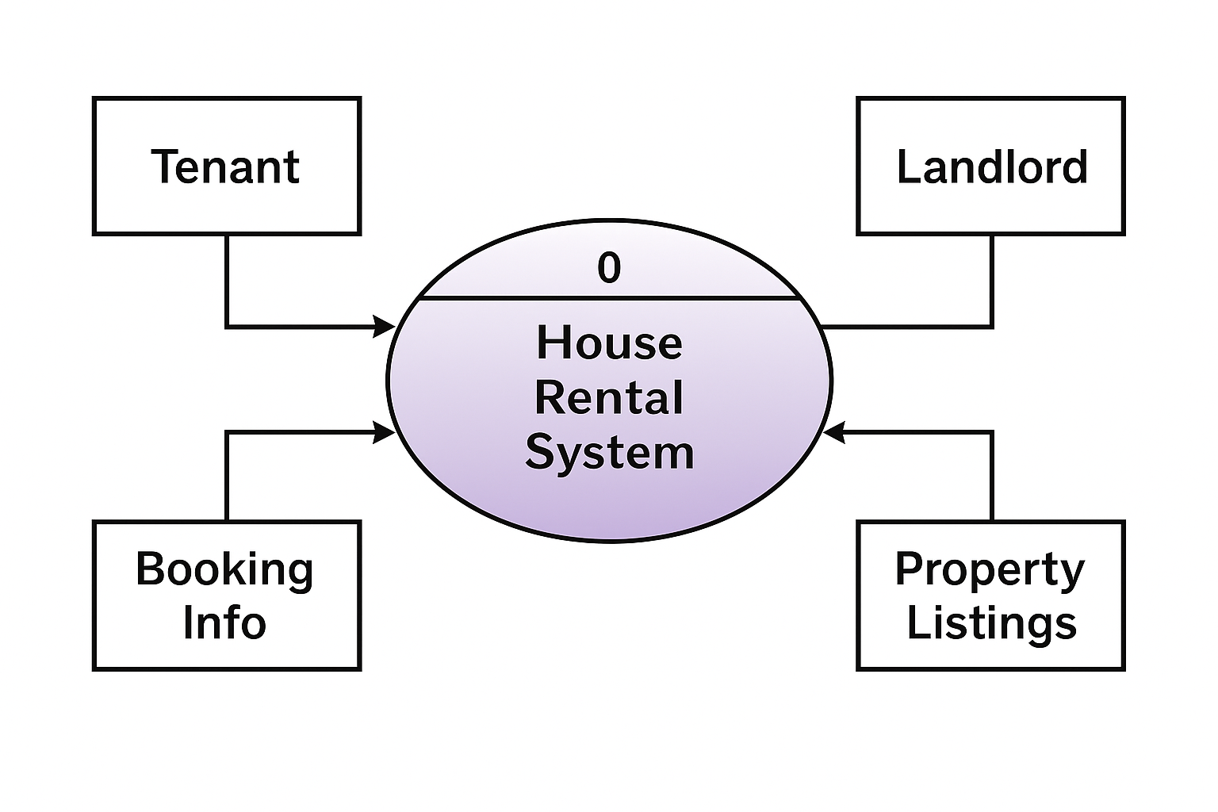

1nd Level Data Flow Diagram:

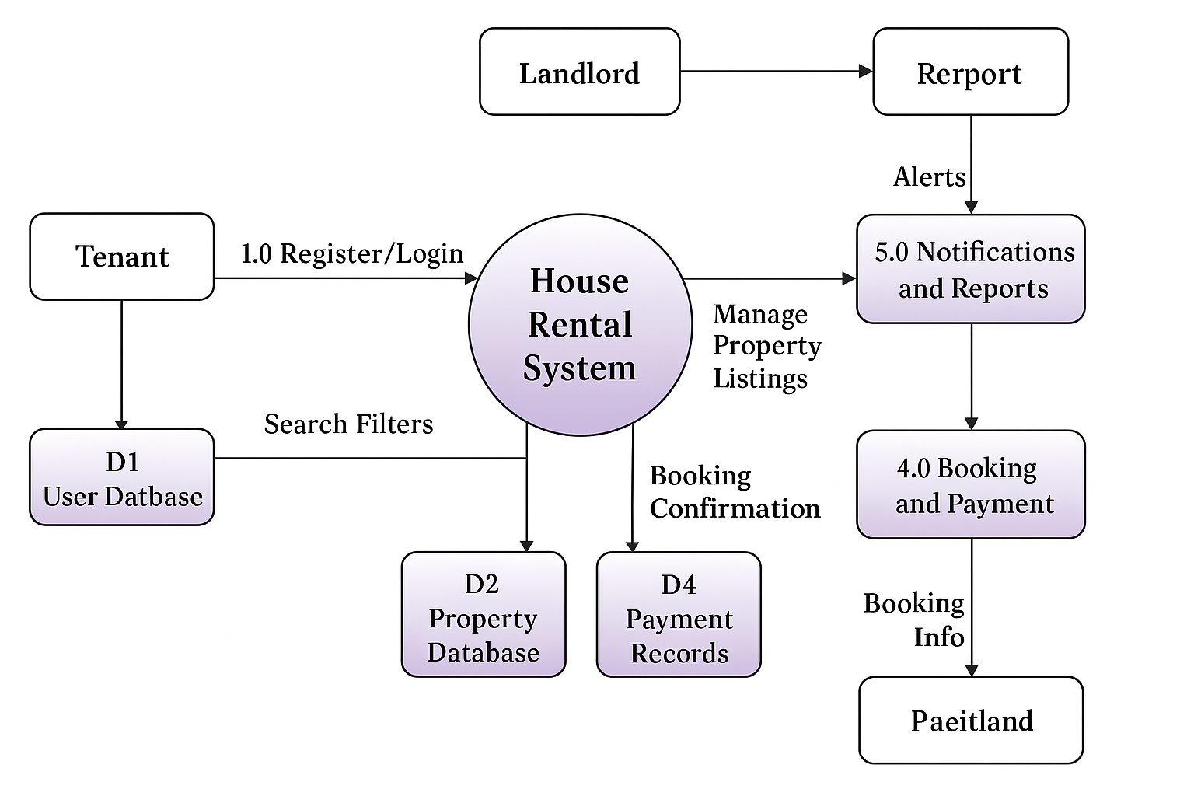

2nd Level Data Flow Diagram:

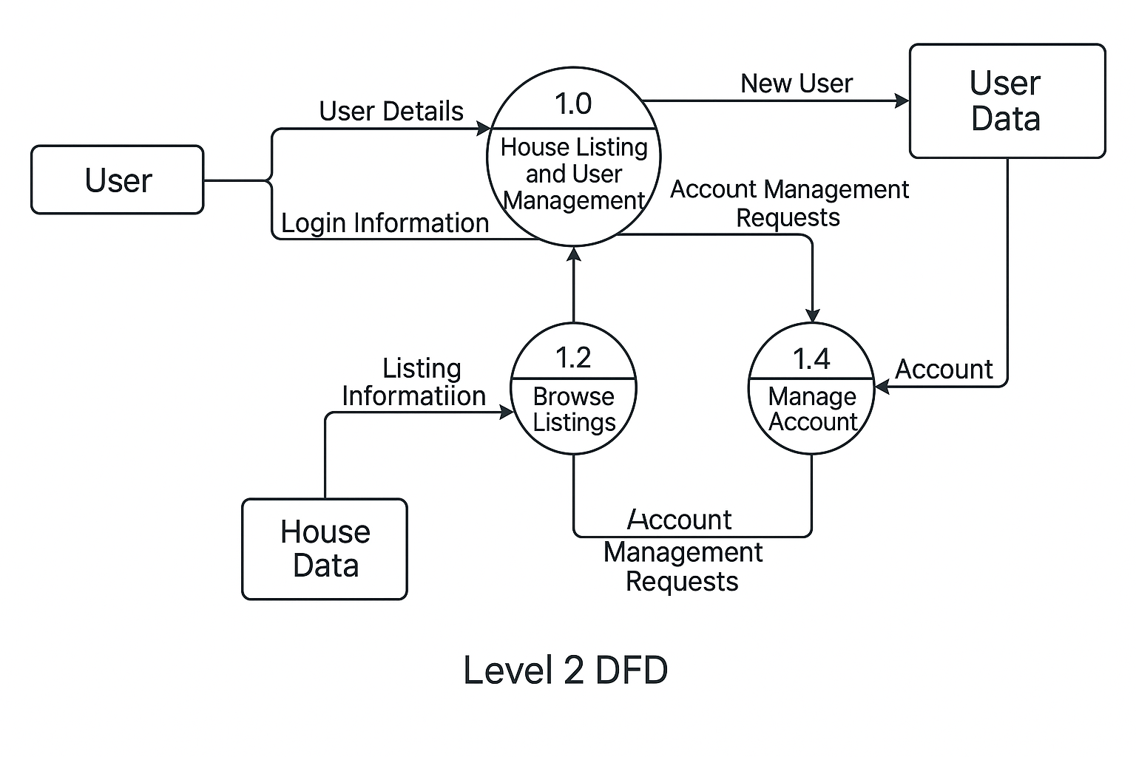

3rd Level Data Flow Diagram:

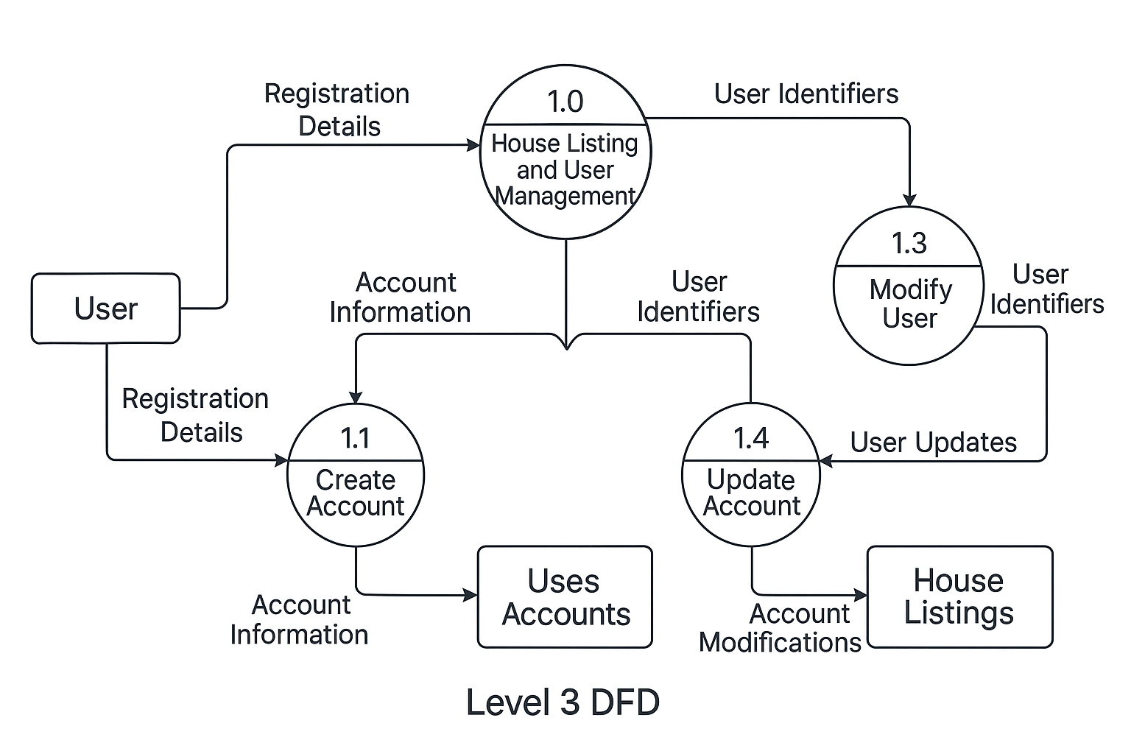

**ERD DIAGRAM :**

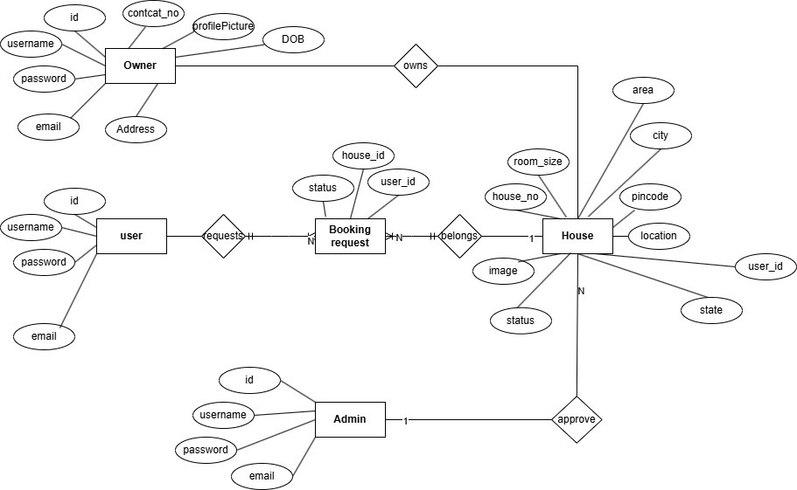

SYSTEM DESIGN

**The various modules used in the project are as follows:**

**MODULES AND THEIR DESCRIPTION**

The various modules used in the House Rental System project are as follows:

a) User Registration and Login

This module allows users to create accounts and access the system. Users include tenants (customers), landlords (property owners), and admins.

* Users provide details like name, email, phone number, username, and password.
* Landlords provide additional details such as address and ID proof.
* Secure login system with role-based access.
* Admins approve landlord accounts before they can list properties.

b) Property Listing Management

This module handles the addition, update, and removal of rental property listings by landlords.

* Landlords can add property details such as title, location, rent, images, description, and availability status.
* Properties are categorized based on type (e.g., apartment, bungalow, PG).
* Landlords can view and manage their listed properties.

c) Property Browsing and Search

This module allows tenants to browse available rental properties and apply filters for easier search.

* Filters include location, rent range, property type, and availability.
* Each listing displays essential information such as rent, images, property type, and landlord contact.
* Tenants can view full property details on a separate page.

d) Booking & Request System

This module manages property booking or rental requests from tenants.

* Tenants can send rental requests or schedule property visits.
* Landlords receive booking notifications and can approve or reject requests.
* Booking history is maintained for both tenants and landlords.

e) Admin Control Panel

The admin panel provides complete control over platform activities and user management.

* Approves or rejects landlord registrations.
* Monitors all user activities and bookings.
* Manages property categories, maintains database consistency.
* **Generates reports on platform usage and property listing statistics.**

**User Registration** – This module allows **customers** and **farmers** to register on the EFarming platform.

* + Users provide information such as name, username, password, phone number, and email.
  + Farmers provide additional details like address, city, and profile image.
  + Once registered, users can log in without re-entering details using stored credentials.
  + Admins approve farmer accounts before they gain access.

**Category Management-** This module handles the display and organization of product categories such as Vegetables, Fruits, Grains, and Dairy.

* + Admin can add, edit, or delete categories.
  + Customers browse products using categories.
  + Farmers assign products to categories while listing

**Product Information**– This section provides thumbnail view of currently running movies along with necessary information in brief.

* + Includes product name, image, description, category, and price.
  + Customers can view all available products and use search or filters.
  + Each product is linked to the farmer who listed it.

**Cart & Booking**– s module allows customers to **add products to a cart** and **place orders (bookings)**.

* + Cart allows users to review and update selected items.
  + Upon confirming the cart, a booking is created.
  + Bookings are linked to the customer and the respective farmers

**Admin Control**– The admin panel provides comprehensive **system oversight and configuration tools**.

* + Approves or blocks users (especially farmers).
  + Manages categories, monitors bookings, and maintains database .

▪ **DATA STRUCTURE OF ALL MODULES:**

# Table Name: adminapp_bookingrequest

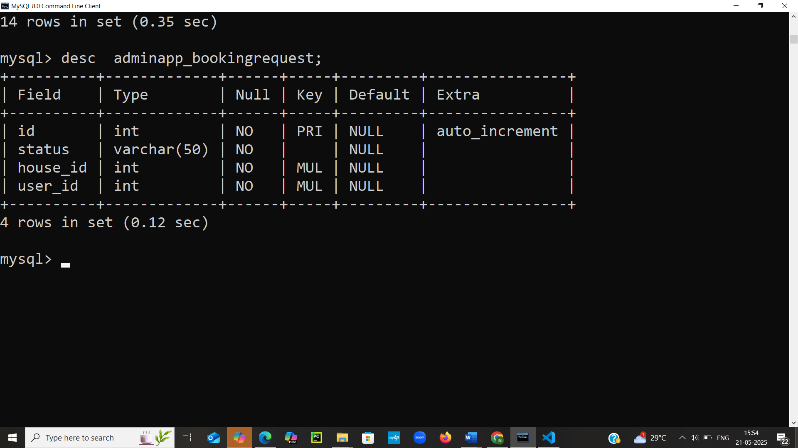

# Table Name: adminapp_house

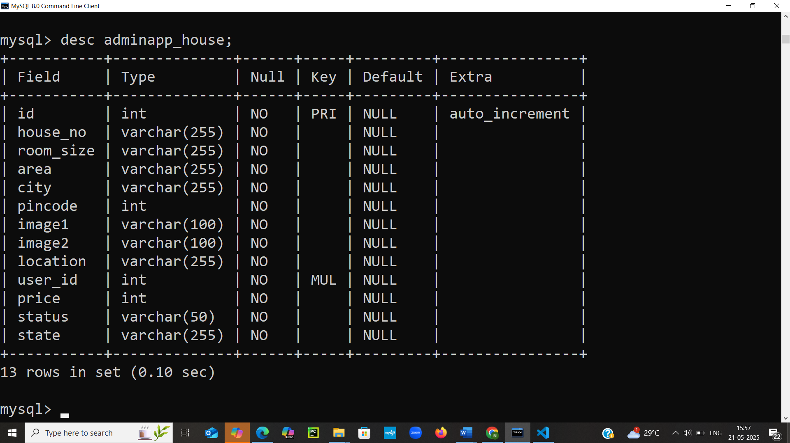

# Table Name : houserentmanagementapp_userprofile

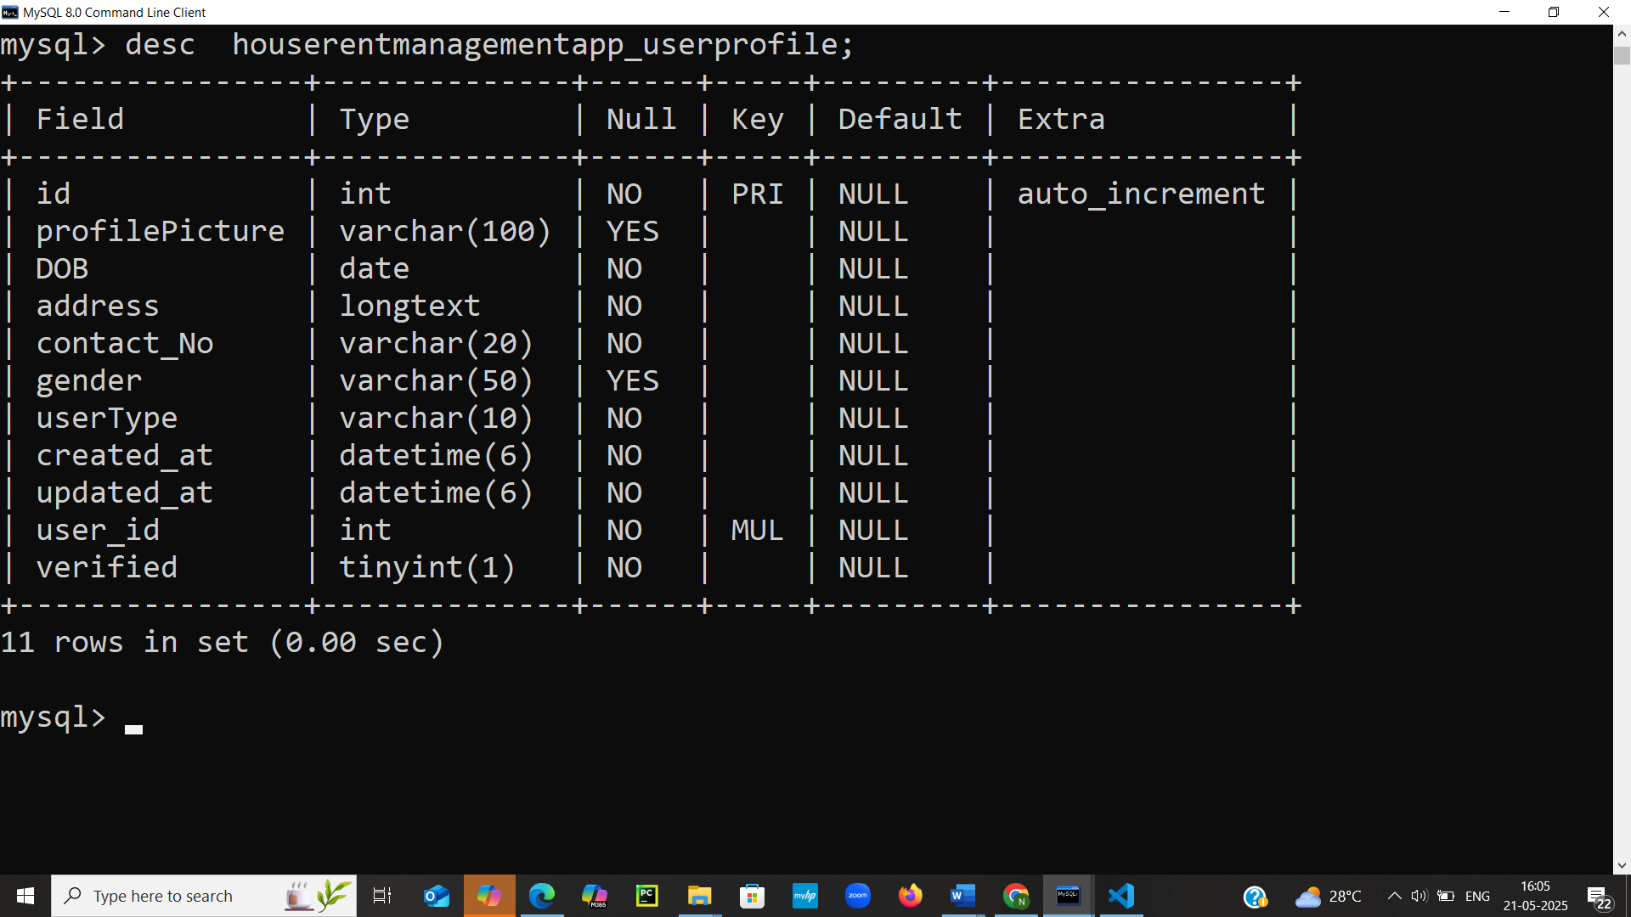

▪ **PROCEDURAL DESIGN**

**User FlowChart:**

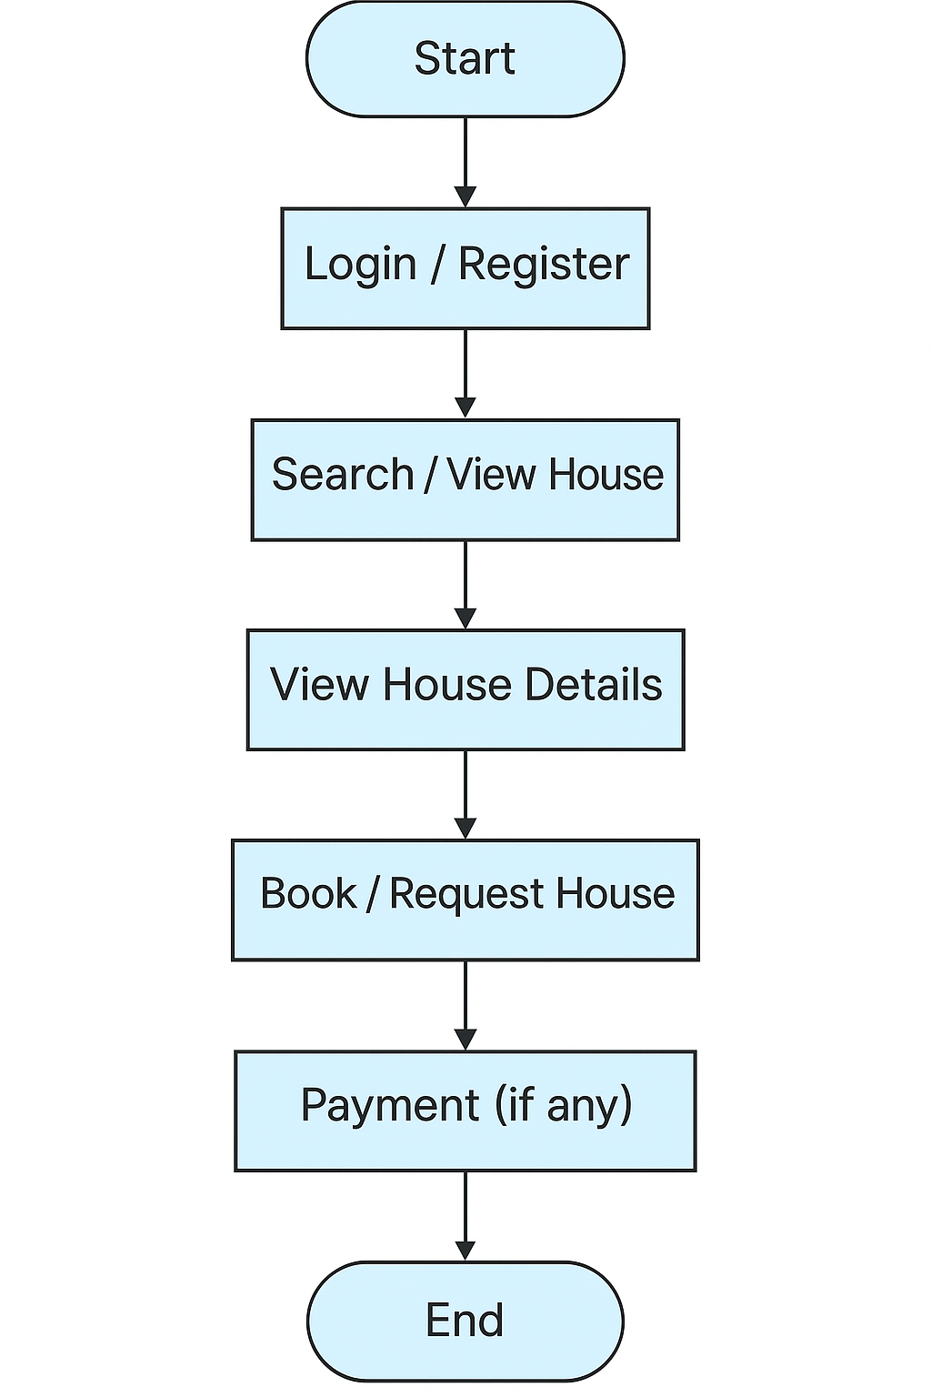

**FlowChart Diagram:**

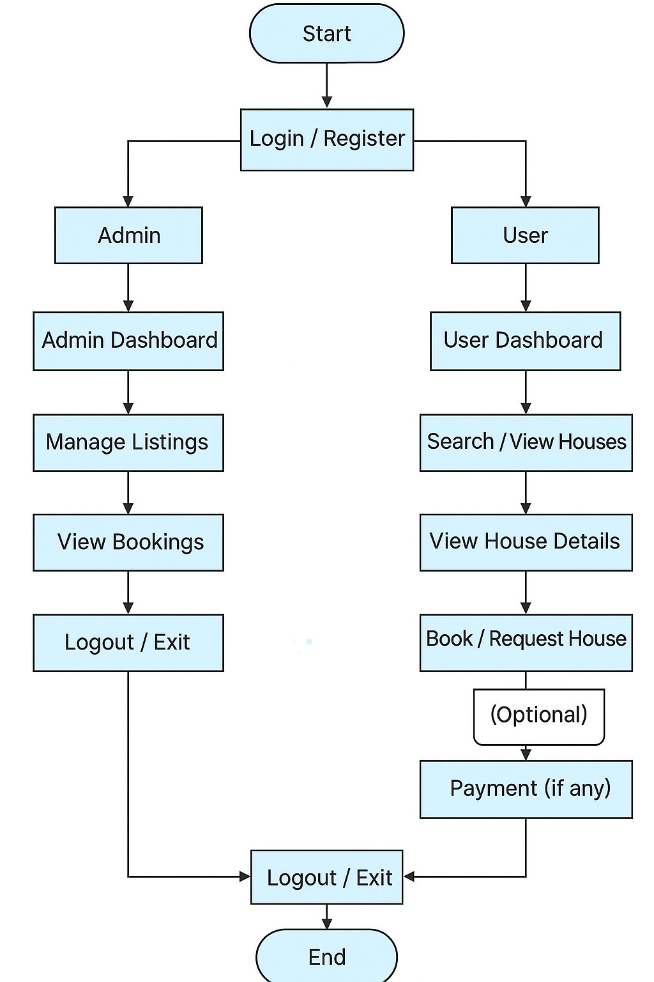

**Admin FlowChart:**

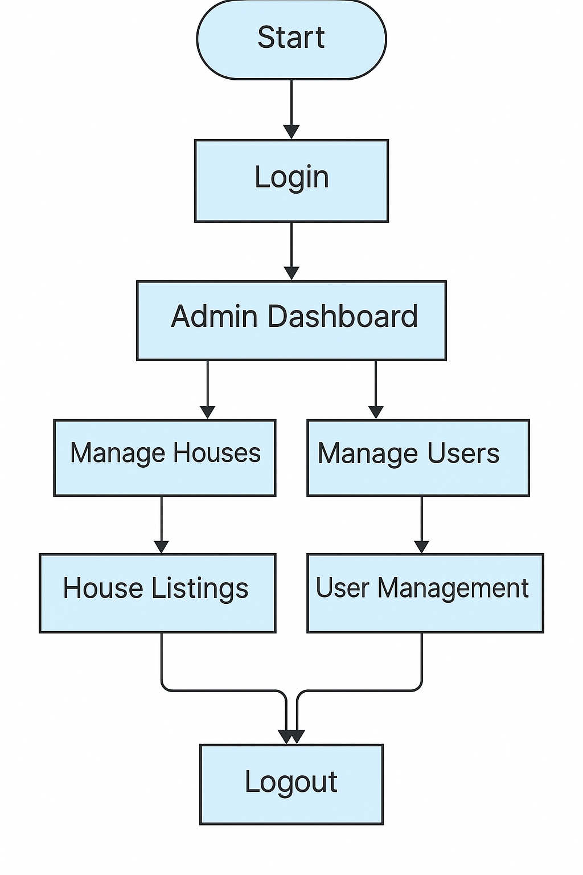

**LIST OF REPORTS THAT ARE LIKELY TO BE GENERATED**

**LIST OF REPORTS FOR HOUSE RENTAL SYSTEM**

1. **Category-wise Property Listings Report**
   * View all properties grouped by category (e.g., Apartment, Villa, Studio, PG).
   * Useful for filtering and analyzing types of accommodations offered.
2. **Owner-wise and City-wise Property Distribution Report**
   * Generate listings showing which owners have posted how many properties.
   * Segment properties by cities or localities for regional trends.
3. **Daily / Weekly / Monthly / Yearly Bookings Report**
   * Track property booking patterns over different timeframes.
   * Useful to observe peak rental seasons or months with lower demand.
4. **Revenue Generated from Rentals Report**
   * Calculate total rent collected from all confirmed bookings.
   * Filter by date, owner, or city for targeted revenue insights.
5. **Booking Trends by Property Type Report**
   * Analyze demand trends based on property type (e.g., Apartments vs. Villas).
   * Helps to understand customer preferences and future investment focus.
6. **Most Booked Properties and Top Landlords Report**
   * Rank properties with the highest booking count.
   * Identify landlords with consistent occupancy and listing performance.
7. **Tenant Feedback and Rating Summary Report**
   * Collect feedback from tenants per property.
   * Show average ratings and top-rated rentals to promote quality.
8. **Vacancy Duration Report**
   * List how long each property stays vacant before being rented.
   * Helps owners optimize pricing and listing strategies.
9. **Payment Status and Pending Transactions Report**
   * Highlight all pending, failed, or partial payments.
   * Useful for financial follow-ups and automated reminders.
10. **Lease Expiry and Renewal Forecast Report**

* List all active leases nearing expiration.
* Helps plan renewals, property relisting, or tenant notifications.

**CODING**

**House Rent Project:**

**Setting.py:**

import os

from pathlib import Path

# Build paths inside the project like this: BASE_DIR / 'subdir'.

BASE_DIR = Path(__file__).resolve().parent.parent

TEMPLATE_DIR=os.path.join(BASE_DIR,'templates')

# Quick-start development settings - unsuitable for production

# See https://docs.djangoproject.com/en/3.1/howto/deployment/checklist/

# SECURITY WARNING: keep the secret key used in production secret!

SECRET_KEY = '9$x0kn7t16=s9ivqy4=qb=mj5(9y+c!1hh3belr@cbg2c#3wzs'

# SECURITY WARNING: don't run with debug turned on in production!

DEBUG = True

ALLOWED_HOSTS = []

# Application definition

INSTALLED_APPS = [

    'django.contrib.admin',

    'django.contrib.auth',

    'django.contrib.contenttypes',

    'django.contrib.sessions',

    'django.contrib.messages',

    'django.contrib.staticfiles',

    'HouseRentManagementApp',

    'AdminApp',

]

MIDDLEWARE = [

    'django.middleware.security.SecurityMiddleware',

    'django.contrib.sessions.middleware.SessionMiddleware',

    'django.middleware.common.CommonMiddleware',

    'django.middleware.csrf.CsrfViewMiddleware',

    'django.contrib.auth.middleware.AuthenticationMiddleware',

    'django.contrib.messages.middleware.MessageMiddleware',

    'django.middleware.clickjacking.XFrameOptionsMiddleware',

]

ROOT_URLCONF = 'houserentproject.urls'

TEMPLATES = [

    {

        'BACKEND': 'django.template.backends.django.DjangoTemplates',

        'DIRS': [TEMPLATE_DIR],

        'APP_DIRS': True,

        'OPTIONS': {

            'context_processors': [

                'django.template.context_processors.debug',

                'django.template.context_processors.request',

                'django.contrib.auth.context_processors.auth',

                'django.contrib.messages.context_processors.messages',

            ],

        },

    },

]

WSGI_APPLICATION = 'houserentproject.wsgi.application'

# Database

# https://docs.djangoproject.com/en/3.1/ref/settings/#databases

DATABASES = {

    'default': {

        'ENGINE': 'django.db.backends.mysql',

        'NAME': 'house_rent_db',

        'USER': 'root',

        'PASSWORD': 'root',

        'HOST': 'localhost',

        'PORT': '3306',

    }

}

# Password validation

# https://docs.djangoproject.com/en/3.1/ref/settings/#auth-password-validators

AUTH_PASSWORD_VALIDATORS = [

    {

        'NAME': 'django.contrib.auth.password_validation.UserAttributeSimilarityValidator',

    },

    {

        'NAME': 'django.contrib.auth.password_validation.MinimumLengthValidator',

    },

    {

        'NAME': 'django.contrib.auth.password_validation.CommonPasswordValidator',

    },

    {

        'NAME': 'django.contrib.auth.password_validation.NumericPasswordValidator',

    },

]

# Internationalization

# https://docs.djangoproject.com/en/3.1/topics/i18n/

LANGUAGE_CODE = 'en-us'

TIME_ZONE = 'UTC'

USE_I18N = True

USE_L10N = True

USE_TZ = True

# Static files (CSS, JavaScript, Images)

# https://docs.djangoproject.com/en/3.1/howto/static-files/

STATIC_URL = '/static/'

MEDIA_URL = '/media/'

MEDIA_ROOT = os.path.join(BASE_DIR, 'media')

EMAIL_BACKEND = 'django.core.mail.backends.smtp.EmailBackend'

EMAIL_HOST = 'smtp.gmail.com'

EMAIL_PORT = 587

EMAIL_HOST_USER = 'erentalhouse.service@gmail.com'

EMAIL_HOST_PASSWORD = 'igitmca#37'

EMAIL_USE_TLS = True

**Urls.py:**

from django.contrib import admin

from django.urls import path

#from HouseRentManagementApp import views

from HouseRentManagementApp.views import (

    IndexPage,

    AboutPage,

    ContactPage,

    ServicesPage,

    LoginPage,

    Logout,

    SignPage,

    OwnerSign,

    ForgotPage,

    ForgotPassword,

    SendEmailForForgotPassword

    )

from AdminApp.views import (

    AllUser,

    ViewUser,

    AddAdmin,

    Profile,

    DeleteUser,

    ChangePassword,

    EditProfile,

    EditHouse,

    RentHouse,

    ViewHouse,

    MyBooking,

    AddHouse,

    CustomerRequest,

    BookHouse,

    DeletePublicBooking,

    MyHouse,

    Location,

    HelpDesk,

    AdminHelpDesk,

    ApproveOwner,

    ApproveAdmin,

    ApprovedCustomer,

    ApproveOwnerRequest,

    ApproveCustomerRequest,

    ConfirmBooking,

    AvailableHouse,

    Dashboard

)

from django.conf.urls.static import static

from django.conf import settings

urlpatterns = [

    path('admin/', admin.site.urls),

    path('',IndexPage,name='index') ,

    path('about/', AboutPage, name='about'),

    path('contact/', ContactPage, name='contact'),

    path('services/', ServicesPage),

    path('login/', LoginPage, name='login'),

    path('logout/', Logout, name='logout'),

    path('sign/', SignPage, name='sign'),

    path('owner-sign/', OwnerSign, name='owner-sign'),

    path('forgot/', ForgotPage),

    path('forgotpassword/',ForgotPassword,name='forgotpassword'),

    path('sendotp/',SendEmailForForgotPassword,name="sendotp"),

    path('change-password/', ChangePassword, name="change-password"),

    path('profile/',Profile,name='profile'),

    path('delete-user/<int:id>/', DeleteUser, name='delete-user'),

    path('edit-profile/<int:id>/', EditProfile, name='edit-profile'),

    path('edit-house/<int:id>/', EditHouse, name='edit-house'),

    path('my-house/', MyHouse, name='my-house'),

    path('add-house/', AddHouse, name='add-house'),

    path('rent-house/', RentHouse, name='rent-house'),

    path('view-house/<int:id>/', ViewHouse, name='view-house'),

    path('book-house/<int:id>/', BookHouse, name='book-house'),

    path('delete-booking/<int:id>/', DeletePublicBooking, name='delete-booking'),

    path('my-booking/', MyBooking, name="my-booking"),

    path('customer-request/', CustomerRequest, name="customer-request"),

    path('helpdesk/', HelpDesk, name='helpdesk'),

    path('admin-helpdesk/', AdminHelpDesk, name='admin-helpdesk'),

    path('all-user/', AllUser, name='all-user'),

    path('view-user/<int:id>/', ViewUser, name='view-user'),

    path('add-admin/', AddAdmin, name='add-admin'),

    path('approve-owner/', ApproveOwner, name='approve-owner'),

    path('approve-admin/', ApproveAdmin, name='approve-admin'),

    path('approved-customer/', ApprovedCustomer, name='approved-customer'),

    path('approve-owner-request/<int:id>/', ApproveOwnerRequest, name='approve-owner-request'),

    path('approve-customer-request/<int:id>/', ApproveCustomerRequest, name='approve-customer-request'),

    path('confirm-booking/<int:id>/', ConfirmBooking, name='confirm-booking'),

    path('available-house/<int:id>/', AvailableHouse, name='available-house'),

    path('location/<int:id>/', Location, name='location'),

    path('dashboard/', Dashboard, name='dashboard')

]+ static(settings.MEDIA_URL, document_root=settings.MEDIA_ROOT)

**Adminapp**

**admin.py:**

from django.contrib import admin

from .models import House

# Register your models here.

admin.site.register(House)

**apps.py:**

from django.apps import AppConfig

class AdminappConfig(AppConfig):

    name = 'AdminApp'

**models.py:**

from django.db import models

from HouseRentManagementApp.models import UserProfile

# Create your models here.

class House(models.Model):

    STATUS = [

        ('Available', 'Available'),

        ('Booked','Booked'),

    ]

    user = models.ForeignKey(UserProfile, on_delete=models.CASCADE)

    house_no = models.CharField(max_length=255)

    room_size = models.CharField(max_length=255)

    area = models.CharField(max_length=255)

    city = models.CharField(max_length=255)

    pincode = models.IntegerField()

    state = models.CharField(max_length=255)

    image1 = models.ImageField()

    image2 = models.ImageField()

    location = models.CharField(max_length=255)

    status = models.CharField(max_length=50, choices=STATUS, default="Available")

    price = models.IntegerField()

    def __str__(self):

        return self.house_no

class BookingRequest(models.Model):

    STATUS = [

        ('Pending', 'Pending'),

        ('Accepted', 'Accepted'),

        ('Rejected', 'Rejected'),

        ('Booked','Booked'),

    ]

    user = models.ForeignKey(UserProfile, on_delete=models.CASCADE)

    house = models.ForeignKey(House, on_delete=models.CASCADE)

    status = models.CharField(max_length=50, choices=STATUS, default="Pending")

**HouseRentManagementApp :**

**admin.py:**

from django.contrib import admin

from .models import UserProfile,OTP

# Register your models here.

class UserAdmin(admin.ModelAdmin):

    list_display=['id','user']

admin.site.register(UserProfile,UserAdmin)

admin.site.register(OTP)

**apps.py:**

from django.apps import AppConfig

class HouserentmanagementappConfig(AppConfig):

    name = 'HouseRentManagementApp'

**models.py:**

from django.db import models

from django.contrib.auth.models import User

import random

# Create your models here.

class UserProfile(models.Model):

    USER_TYPES = [

        ('Public', 'Public'),

        ('Owner','Owner'),

        ('Admin', 'Admin'),

    ]

    user=models.ForeignKey(User,on_delete=models.CASCADE)

    profilePicture = models.ImageField(blank=True, null=True)

    DOB = models.DateField()

    address = models.TextField()

    contact_No = models.IntegerField()

    gender=models.CharField(max_length=50,null=True,blank=True)

    userType = models.CharField(max_length=10, choices=USER_TYPES, default='Public')

    verified = models.BooleanField(default=False)

    created_at = models.DateTimeField(auto_now_add=True)

    updated_at = models.DateTimeField(auto_now=True)

    def __str__(self):

        return self.user.username

class OTP(models.Model):

    def Get_OTP():

        return random.randint(100000, 999999)

    user = models.ForeignKey(User, on_delete=models.CASCADE)

    otp = models.IntegerField(default=Get_OTP)

    created_at = models.DateTimeField(auto_now_add=True)

    def __str__(self):

        return self.user.username

**Templates :**

**Contact.html**

{% extends 'base.html' %}

{% load static %}

{% block content %}

    <section class="hero-wrap hero-wrap-2 ftco-degree-bg js-fullheight" style="background-image: url('/static/images/bg_1.jpg');" data-stellar-background-ratio="0.5">

      <div class="overlay"></div>

      <div class="container">

        <div class="row no-gutters slider-text js-fullheight align-items-center justify-content-center">

          <div class="col-md-9 ftco-animate pb-5 text-center">

            <p class="breadcrumbs"><span class="mr-2"><a href="/">Home <i class="ion-ios-arrow-forward"></i></a></span> <span>Contact <i class="ion-ios-arrow-forward"></i></span></p>

            <h1 class="mb-3 bread">Contact us</h1>

          </div>

        </div>

      </div>

    </section>

    <section class="ftco-section contact-section">

      <div class="container">

        <div class="row d-flex mb-5 contact-info justify-content-center">

          <div class="col-md-8">

            <div class="row mb-5">

              <div class="col-md-4 text-center py-4">

                <div class="icon">

                  <span class="icon-map-o"></span>

                </div>

                <p><span>Address:</span> igit,sarang,Dhenkanal</p>

              </div>

              <div class="col-md-4 text-center border-height py-4">

                <div class="icon">

                  <span class="icon-mobile-phone"></span>

                </div>

                <p><span>Phone:</span> <a href="tel://1234567920">+91 8989157416</a></p>

              </div>

              <div class="col-md-4 text-center py-4">

                <div class="icon">

                  <span class="icon-envelope-o"></span>

                </div>

                <p><span>Email:</span> <a href="mailto:info@yoursite.com">erentalhouse.service@gmail.com</a></p>

              </div>

            </div>

          </div>

        </div>

        <div class="row block-9 justify-content-center mb-5">

          <div class="col-md-8 mb-md-5">

      <h2 class="text-center">If you got any questions <br>please do not hesitate to send us a message</h2>

            <form action="/contact/" method="POST" class="bg-light p-5 contact-form">

              {% csrf_token %}

              <div class="form-group">

                <input type="text" name="name" class="form-control" placeholder="Your Name" required>

              </div>

              <div class="form-group">

                <input type="text" name="email" class="form-control" placeholder="Your Email" required>

              </div>

              <div class="form-group">

                <input type="text" name="subject" class="form-control" placeholder="Subject" required>

              </div>

              <div class="form-group">

                <textarea name="message" cols="30" rows="7" class="form-control" placeholder="Message" required></textarea>

              </div>

              <div class="form-group">

                <input type="submit" value="Send Message" class="btn btn-primary py-3 px-5">

              </div>

            </form>

          </div>

        </div>

        <div class="row justify-content-center">

          <div class="col-md-10">

            <div id="map" class="bg-white"></div>

          </div>

        </div>

      </div>

    </section>

    {% endblock content %}

**Login.html:**

<!DOCTYPE html>

{% load static %}

<html>

<head>

<link rel="stylesheet" href="{% static 'css/ab.css' %}">

<title> login</title>

</head>

<body>

  <body>

    <div class="login-page">

      <div class="form">

        <div class="login">

          <div class="login-header">

            <h3><a href="/">Home</a></h3>

            <h3>LOGIN</h3>

            <p>Please enter your credentials to login.</p>

          </div>

        </div>

        <form class="login-form" method="POST" action="/login/" enctype="multipart/form-data">

          {% csrf_token %}

          {% if msg %}

          <center style="color: red;">{{msg}}</center>

          {% endif %}

          <input type="text" name="username" placeholder="username" required/>

          <input type="password" name="password" placeholder="password" required/>

          <button type="submit" class="btn btn-primary" style="color:blue;">Login</button>

          <p class="message"> <a href="/forgot/">Forgot Password</a></p>

          <p class="message"> Don't have an Account??<a href="/sign/">Create One.</a></p>

        </form>

      </div>

    </div>

</body>

</body>

</html>

**Manage.py**

import os

import sys

def main():

    """Run administrative tasks."""

    os.environ.setdefault('DJANGO_SETTINGS_MODULE', 'houserentproject.settings')

    try:

        from django.core.management import execute_from_command_line

    except ImportError as exc:

        raise ImportError(

            "Couldn't import Django. Are you sure it's installed and "

            "available on your PYTHONPATH environment variable? Did you "

            "forget to activate a virtual environment?"

        ) from exc

    execute_from_command_line(sys.argv)

if __name__ == '__main__':

    main()

**ERROR HANDLING**

Errors indicate the inaccuracy or instability of a system. A project is only considered complete when\

it produces error-free and reliable output. Identifying and handling errors is crucial in the development

of the Errors in the House Rental System are broadly categorized as:

**1. Syntax Errors:**

These errors occur when the developer fails to follow the programming language's grammar rules.

* **Example in Python:** Missing colon, unmatched parentheses, or incorrect indentation.
* **Example in HTML/JS:** Unclosed tags, missing semicolons.
* **Identification:** Detected by the interpreter or compiler during the development phase.
* **Fix:** Correct the syntax in the respective code file.

**2. Logical Errors:**

These occur when the program runs without crashing but delivers incorrect output due to faulty logic.

* **Example:** Calculating total rent incorrectly or displaying wrong property details.
* **Identification:** Not caught by the compiler; only detected during thorough testing.
* **Fix:** Perform logic reviews and validate outputs through various test cases.

**3. Runtime Errors:**

These errors are triggered during execution and are often based on real-time inputs or environment

conditions.

**Examples:**

* + Division by zero in rent calculations.
  + Invalid data entry (e.g., empty property name or wrong date format).
  + Database connection failure.
* **Identification:** These are reported by the system during code execution.
* **Fix:** Use try-except blocks in Python and proper validation mechanisms in HTML forms and Javascrpit

**TESTING**

**TESTING STRATEGY**

**Testing** is an investigation carried out to ensure that the House Rental System meets quality standards

and functions correctly. Software testing offers an independent evaluation of the system to help

identify defects and improve functionality before deployment.

The main aim of testing in the House Rental System is to validate and verify that the application:

1. Meets the business and technical requirements outlined during planning;
2. Performs its core functions such as listing properties, user login, booking, and payment processing correctly; and
3. Can be reliably implemented in various real-world usage scenarios.

Testing can be applied at any phase in the software development lifecycle, though it is typically

emphasized after development is complete. The chosen testing strategy depends on the develop

ment methodology being used.

For the House Rental System, the following approaches may be used:

* **Unit Testing**: To test individual components like login, registration, property listing.
* **Integration Testing**: To ensure modules such as the database and frontend are properly connected.
* **System Testing**: To verify the overall system functionality, including admin and user workflow.
* **User Acceptance Testing (UAT)**: To ensure the system meets user expectations in real-life

rental scenarios.

In Agile-like methodologies, testing may be conducted in shorter cycles by the developer, enabling

quicker feedback and fixes. In traditional models, testing is conducted after the development is

completed by a dedicated testing team.

It is important to note that testing cannot guarantee a completely defect-free system. Instead, it provides

a **comparison** between the actual and expected behavior of the application, helping stakeholders

understand the software quality before launch.

**Testing Methods**

Software testing methods for the **House Rental System** are typically categorized into **white-box** and

**black-box** testing. These methods help test engineers and developers ensure that the software behaves

as expected from both the internal logic and external user perspectives.

**Unit Testing**

**Unit testing** for the House Rental System focuses on verifying the correctness of individual components

of the system—such as the login module, registration process, property listing, and booking function

These tests are typically written and executed by developers during the development phase.

In this system, unit tests might include:

* Verifying user input validation in the login and registration modules.
* Ensuring correct data retrieval and display in the property listing component.
* Checking the functionality of the rent calculation and payment modules.
* Testing admin features like adding or removing rental listings.

Each function or class (such as User, Property, Booking, Payment) is tested in isolation to confirm that

it performs its task correctly. This process ensures that the foundational blocks of the system work

properly and can be reliably integrated later.

Unit testing is performed using a **white-box testing approach**, where the internal logic and code

structure are known to the tester. For example:

* In the **user registration module**, tests may verify if the system correctly validates email and password format.
* In the **booking module**, tests might check that bookings cannot be made for already occupied dates.

Unit testing does not validate the entire system but ensures that each individual part is functioning

as intended before integration.

**Unit testing** is also referred to as **component testing**, especially when referring to larger functional

pieces of the application.

**Integration Testing**

**Integration testing** in the House Rental System is performed to verify the interaction between

different modules such as user login, property listing, booking, payment, and admin management.

It ensures that the data flow between these modules is consistent and that they work together as intended.

For example:

* When a user logs in and tries to book a property, the system should correctly fetch available properties, confirm bookings, and update records in the database.
* Integration testing also verifies that payment information is correctly processed and linked to

the booking and user details.

This type of testing helps to identify defects in the interaction between modules—such as incorrect

data transfer or broken links between front-end and back-end operations. Database connectivity is

also tested to ensure that information is correctly stored and retrieved.

**System Testing**

**System testing** is conducted on the fully integrated House Rental System to ensure it meets

specified requirements and functions as a complete solution.

During this phase, the system is tested as a whole, including:

* **User registration and login validation**
* **Search and filter functionality for rental properties**
* **Booking and cancellation flow**
* **Payment processing**
* **Admin controls for managing listings and users**

Each of these functionalities is tested with various input scenarios to ensure the expected output is

delivered, ensuring system reliability and usability.

System testing ensures that the complete system performs its designated tasks effectively and is ready

for real-world use. It validates that the House Rental System delivers accurate results, user satisfaction,

and functional completeness.

**SYSTEM SECURIty**

The **House Rental System** incorporates essential security features to ensure that users’ data and

system operations are protected against unauthorized access or malicious activities. This system

enforces secure login procedures, data encryption, and user-specific access controls.

Users must register and authenticate using a valid username and password to access system features

such as browsing listings, booking properties, or making payments. This ensures that only

authorized users can access sensitive information or perform restricted operations.

**Security Issues Based on ISO 74982:**

* **Authentication:**  
  The system verifies each user's identity during the login process. Only authenticated users can access resources like profile information, booking history, and payment records.
* **Access Control:**  
  The House Rental System uses access control to limit features based on user roles (e.g., admin, property owner, tenant). This ensures that only authorized users can add, delete, or modify property listings or view booking/payment data.
* **Confidentiality:**  
  Sensitive data such as login credentials and payment information is protected using encryption techniques. This ensures that unauthorized users cannot intercept or view private data.
* **Data Integrity:**  
  The system ensures that data (such as property listings, user profiles, and bookings) is accurate and consistent. Any unauthorized or unintended changes to data are prevented, and any detected inconsistencies can be corrected.
* **Non-repudiation:**
  + Each user action is logged, ensuring traceability of who performed which actions (e.g, booking, cancellation, listing update).
  + The system enforces security policies that specify which user roles can execute specific tasks.

**Security Measures Implemented in the House Rental System:**

* Authentication
* Access Control
* Confidentiality
* Data Integrity
* Non-repudiation

**INTERFACE SECURITY**

The **Site Administrator** is the only super user of this system. S/he can:

* Access all system features.
* View and manage rental property listings.
* Approve or reject landlord/property requests.
* View reports and system analytics.

Normal users (such as Tenants and Landlords) have limited access based on their roles. For example:

* **Landlords** can add/edit property listings.
* **Tenants** can browse properties, apply for rentals, and manage their profile.

**REPORT**

home Page :

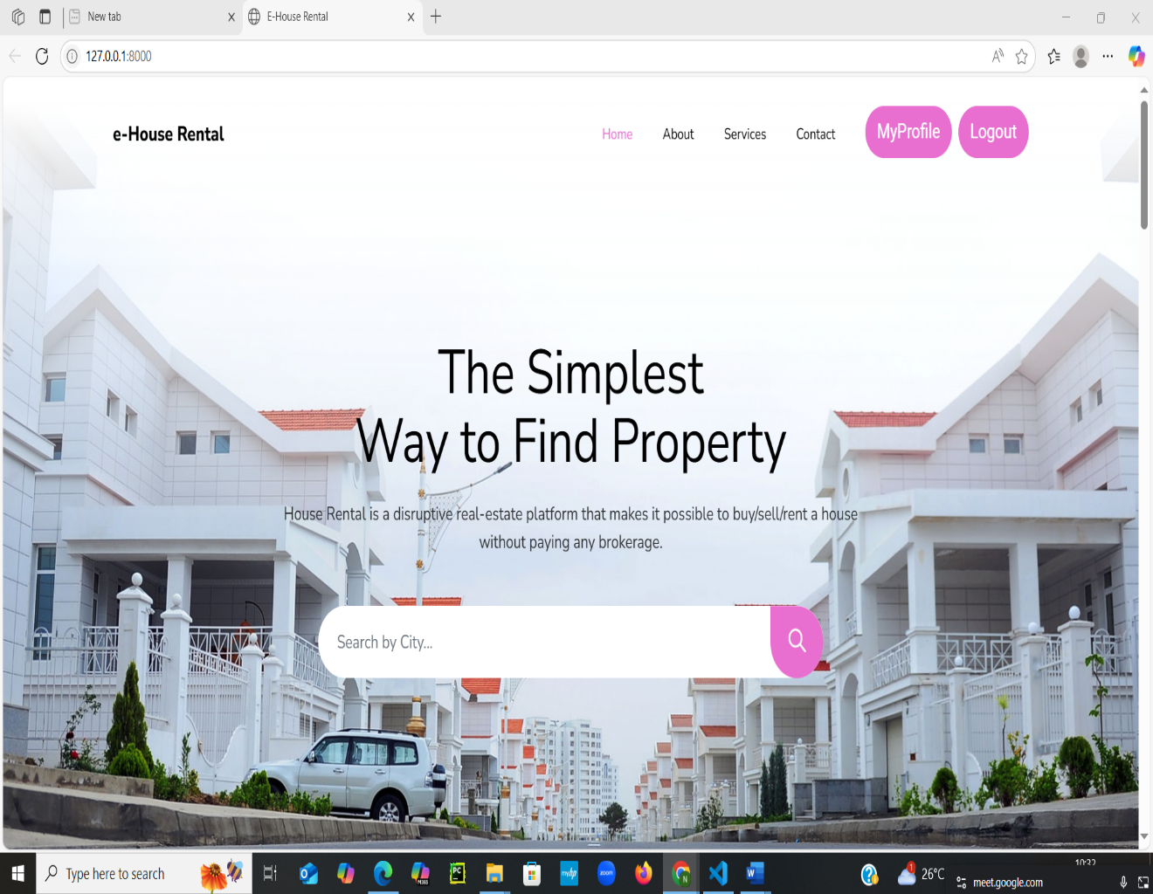

ADMIN PAGE:

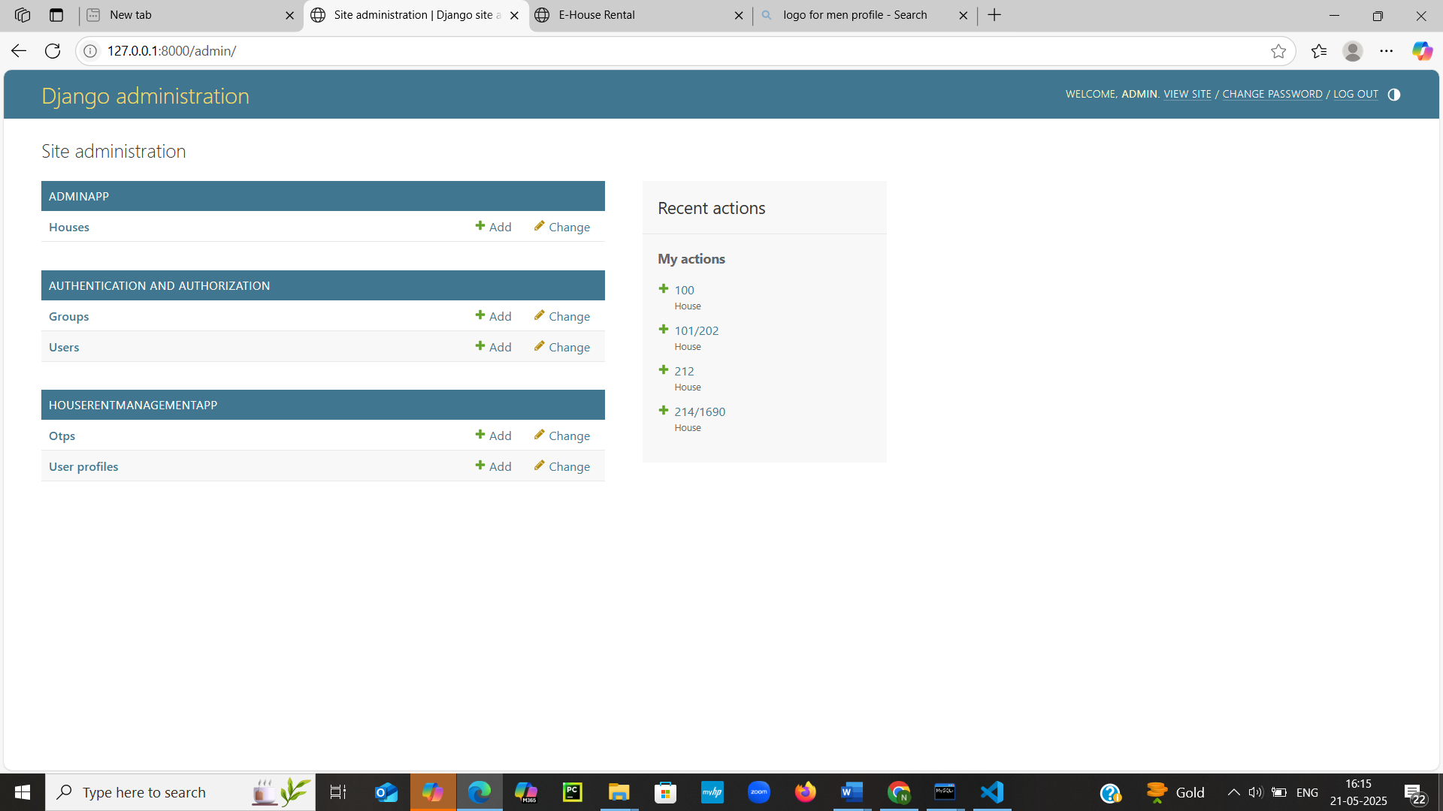

OWNER SIGN IN PAGE:

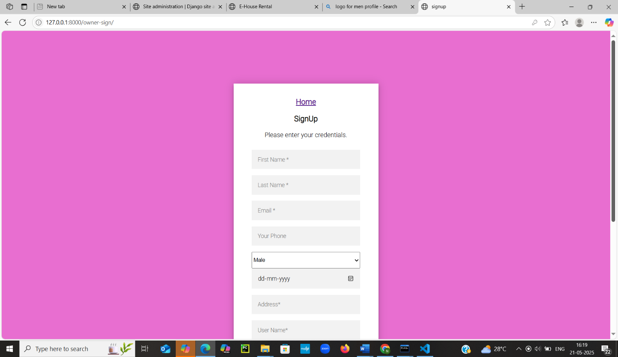

USER LOGIN PAGE:

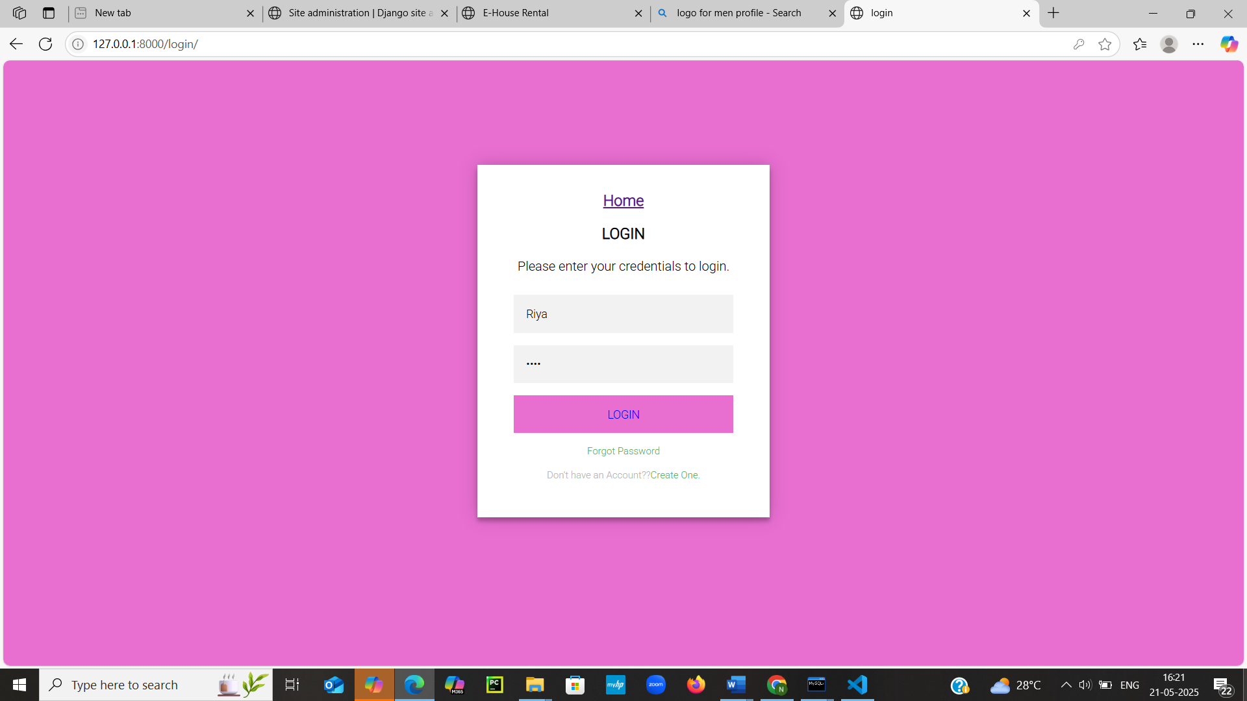

**House For Rent:**

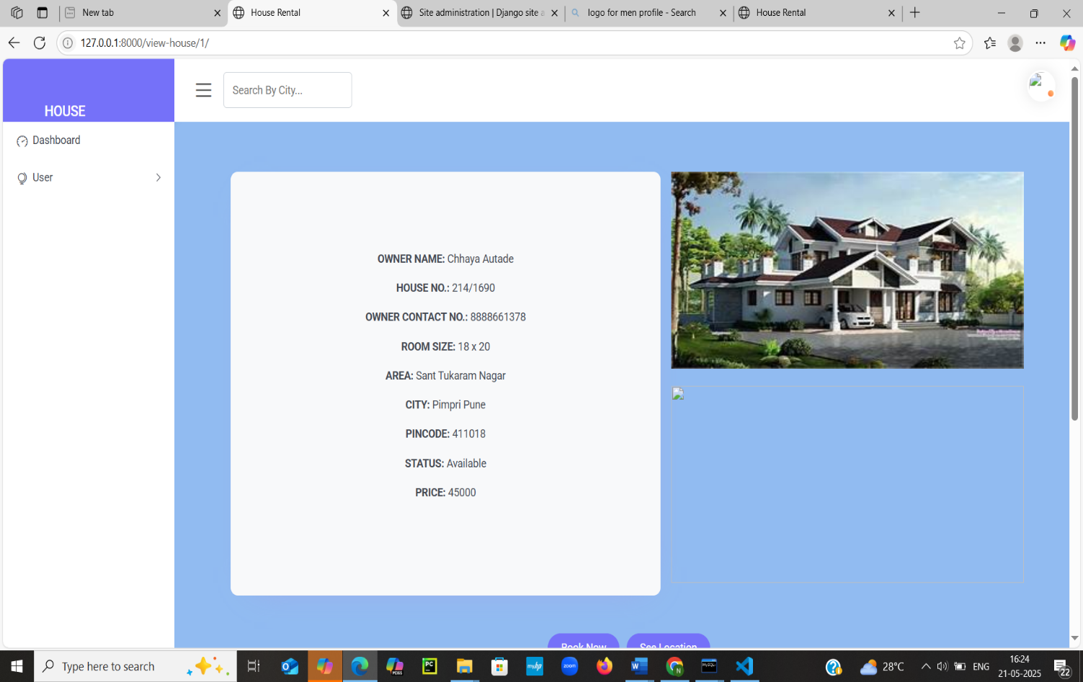

HOUSEs FOR RENt:

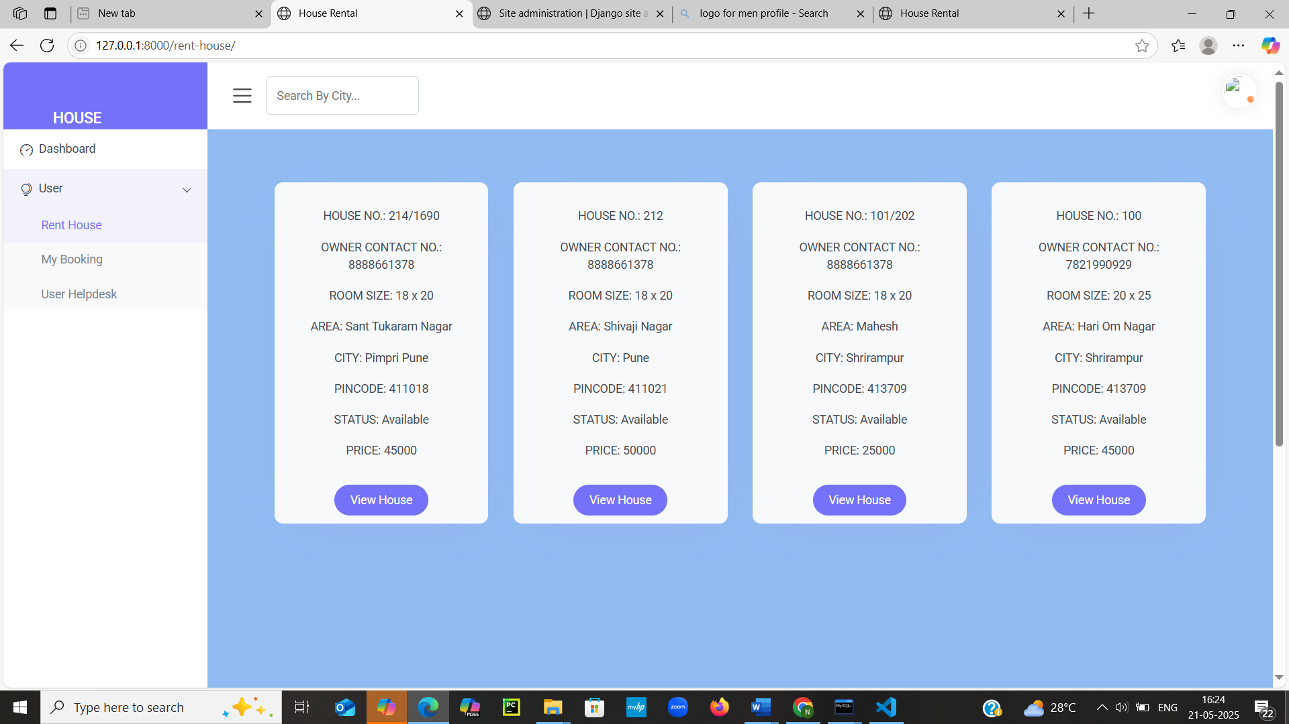

BOOKED HOUSES:

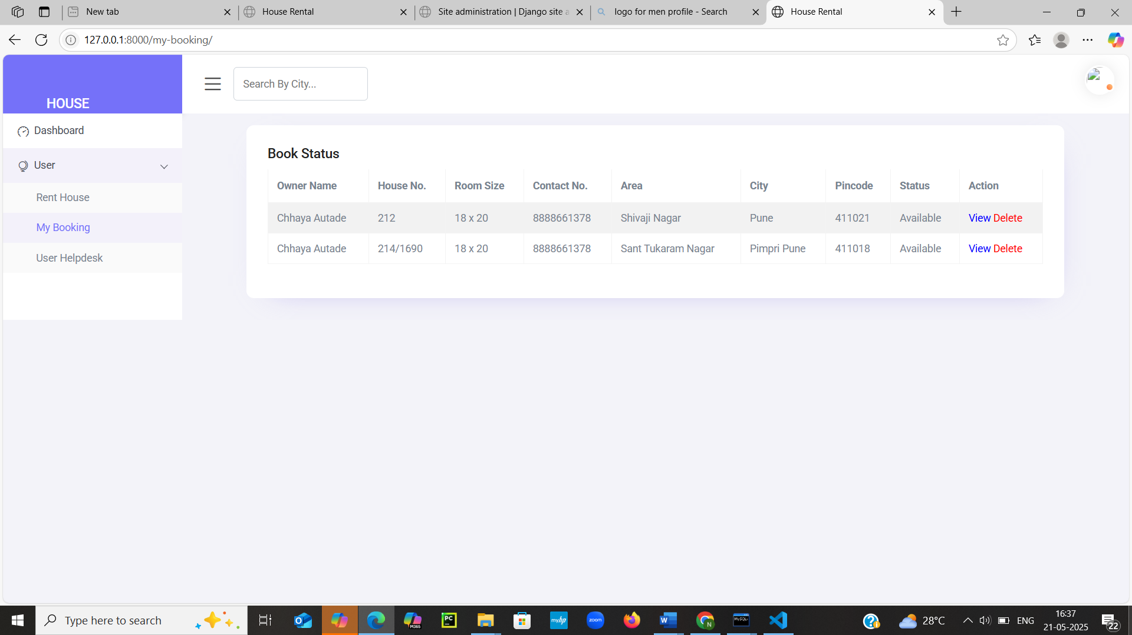

Customer request:

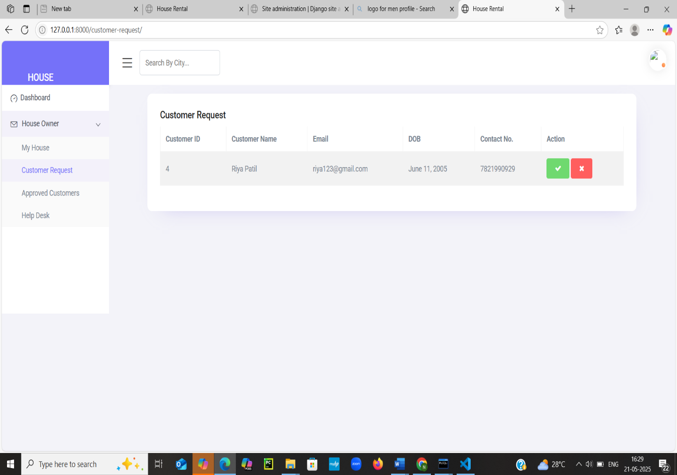

APPROVED REQUEST:

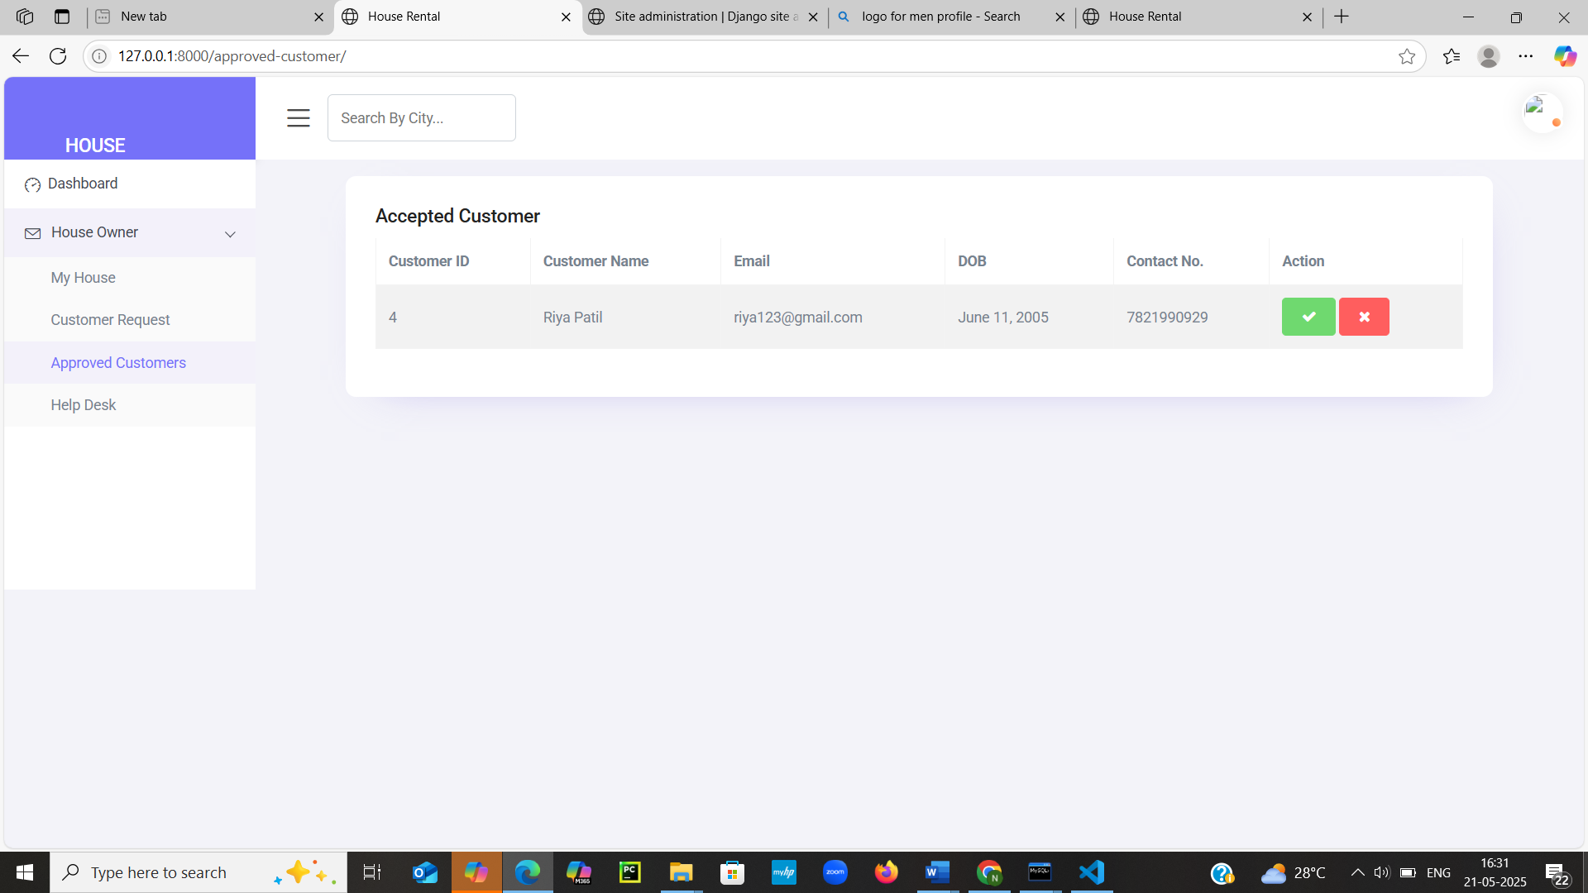

**Future Scope**

**FUTURE SCOPE**

The project named as **“House Rental System”** is a web-based platform that has vast potential i

the real estate rental market. With the growing need for organized, accessible, and user-friendly rental

this platform can be extended and customized for various property dealers, agents, and individual

owners to simplify the rental process and improve communication with tenants.

Traditionally, renting a house involved manual efforts, middlemen, and lots of paperwork. In this

digital age, users prefer faster and more secure methods. Our system bridges this gap

by providing an efficient, easy-to-use interface for property listings, tenant management,

and online communication. It has been developed using **Python**, **SQL**, and **web technologies**

to meet the key requirements of a modern rental system.

Our system enables property owners and tenants to interact smoothly, reducing dependency

on intermediaries and improving service transparency. Through our platform, we aim to simplify

rental management, avoid delays and disputes, and create a reliable digital record of all transactions.

We believe our project effectively fulfills the initial goals and lays a strong foundation for

further developments.

**Further Enhancements**

➤ **Payment Integration**: Online rent payments and deposits through secure payment gateways

can be added, providing ease for both landlords and tenants.

➤ **Mobile Application**: A cross-platform mobile app could be developed for on-the-go access to

property listings and tenant interactions.

➤ **Smart Notifications**: Alerts for due payments, maintenance requests, and agreement renewals can

be automated for better tracking.

➤ **Document Upload & Verification**: Tenants and owners can upload ID proofs, lease agreements,

and ownership documents for verification and transparency.

➤ **AI-Based Recommendations**: Implementing AI to suggest suitable properties based on a

user’s browsing and search patterns.

➤ **Chatbot Support**: Integrating a chatbot to answer frequently asked questions and assist users

with navigation and support.

**Bibliography**

• **Official Documentation**

Python Documentation: <https://docs.python.org>

* MySQL Documentation: <https://dev.mysql.com/doc/>
* Django Framework Docs: <https://docs.djangoproject.com>
* HTML/CSS/JS Reference (MDN): <https://developer.mozilla.org>

• **Web Resources & Tutorials**

* W3Schools: <https://www.w3schools.com> – for HTML, CSS, JavaScript basics.
* GeeksforGeeks: <https://www.geeksforgeeks.org> – tutorials on Python, SQL, Django.
* Stack Overflow: <https://stackoverflow.com> – for troubleshooting and coding solutions.
* FreeCodeCamp: <https://www.freecodecamp.org> – web development tutorials.

• **Development Tools & Platforms**

* Visual Studio Code (VS Code) – Code Editor.
* MySQL Server – Database management.
* Django – Python Web Framework.
* GitHub – Code repository and version control.